Anton Shammas (1950 –)

Anton Shammas is a Palestinian poet, novelist, academic, and translator. He is best known for his 1986 novel ערבסקות/Arabeskot (Arabesques), the first high-profile novel written by a Palestinian in the Hebrew language. Shammas' literary career – as a writer, translator, and scholar – has largely focused on themes of Palestinian and Israeli identity, and the relationship of such identities to language and translation.

[Main text]
Anton Shammas was born in 1950 in the village of Fassuta in the northern Galilee to a Palestinian father and a Lebanese mother who had moved south of the border to work as a schoolteacher. The family moved to Haifa in 1962, and Shammas then headed to Jerusalem, where he studied English and Arabic literature and art history at Hebrew University from 1968-72. He left Israel in 1987, moving to the USA, where he has occupied a number of academic positions, including Professor of Middle Eastern Literature at the University of Michigan.

Shammas' literary activities started in Israel in the 1970s. He was one of the founders of the Arabic-language magazine al-Sharq ( الشرق/The East), which he edited from 1971 to 1976. He also published three collections of poems between 1974 and 1979, two in Hebrew and one in Arabic, and wrote articles which – amongst other subjects – delved into the question of Arab identity in a Jewish state. From 1972 until 1984 Shammas also translated a number of Hebrew books into Arabic, but in the early 1980s his interest appeared to shift to presenting Arabic literature to Hebrew readerships. In 1984 he published the Hebrew edition of one of the best-known novels by a Palestinian author, Emil Habiby's The Secret Life of Saeed the Pessoptimist (الوقائع الغريبة في اختفاء سعيد أبي النحس المتشائل‎ / Al-Waqa'i al ghareebah fi ikhtifa' Sa'id Abi an-Nahs al-Mutashaa'il, originally published in 1974), and followed this with Ikhtiyyeh ( إخطية ) in 1988 and Saraya, the Ogre's Daughter (خرافية سرايا بنت الغول / Khurrafeyyat Sarayah Bint al-Ghoul) in 1993. Apart from Arabesques, Anton Shammas is best known for his Hebrew translations of Habiby.

In 1986, though, Shammas published Arabesques (ערבסקות /Arabeskot), the first significant novel in Hebrew by a Palestinian author (the absolute first was Atallah Mansour's Be-or hadash, in 1966). it was acclaimed by Israeli critics, with Amos Oz calling it ‘a triumph, not necessarily for the Israeli society, but for the Hebrew language’ and Yael Lotan claiming it as the first Israeli (rather than Jewish) novel because ‘is based entirely on Israeli experience’. The novel's English translation also had a considerable impact on publication, receiving lengthy reviews in major literary journals, appearing in 'best of the year' lists and ultimately being translated into at least eight languages. Western literary critics also welcomed its combination of technical prowess and its subtle and complex navigation of the issue of identity in Israeli society.

Arabesques was seen as a novel which displayed virtuosity in terms of Hebrew literary style, but was also recognised as challenging conceptions of what it means to be 'Israeli', since these are often closed wrapped up with Jewish identities. Lotan also suggested that Shammas might ultimately take on a stature in Hebrew literature like that of, for instance, Joseph Conrad in English – the non-native speaker of the language who nevertheless surpasses almost all others in terms of their command of it. But Muhammad Siddiq – like Shammas a Palestinian citizen of Israel – has argued that for Arab writers to be genuinely seen as part of the Israeli canon will necessitate major social and attitudinal changes.

In the wake of the success of Arabesques, Shammas moved to the USA and spent much of the rest of his career at the University of Michigan, whilst also working with various other organisations and publications, including the International Parliament of Writers, of which he was a founding member, and editorial roles at the Journal of Palestine Studies and Banipal, a magazine focusing on translations of Arabic literature into English.

Anton Shammas continued also to translate literature to and from Arabic, Hebrew and English. This has included adapting plays by Dario Fo, Samuel Beckett, Harold Pinter, Edward Albee, and Athol Fugard for Israeli theatre companies (in both Arabic and Hebrew). In 2006, he released a Hebrew edition of the poems of Taha Muhammad Ali – like Emil Habiby and Shammas himself a Palestinian from the Galilee region of northern Israel. This, along with Shammas' editorial involvement in the 2002 Hebrew edition of Elias Khoury's monumental Arabic novel Gate of the Sun ( باب الشمس/ Bab al-shams), a layered and complex intertwining of the establishment of the State of Israel with the 1982 Israeli invasion of Lebanon, highlight the continuity within Shammas' work – a focus on the experience of Palestinians within Israel, the complex challenges which their existence poses to Israeli identity, and the role of literature and translation in negotiating such challenges.

Publications

Prose

The Biggest Liar in the World (children's, Hebrew) (1982)
ערבסקות / Arabeskot / Arabesques. Tel Aviv: Am Oved 1986; English translation New York: Harper & Row
The Retreat From Galilee, Granta 23 (1988)

Poetry

اسير يقظتي ونومي / Imprisoned in my Own Awakening and Sleep (Arabic) (1974)
כריכה קשה / Hardcover (Hebrew) (1974)
שטח הפקר / No Man's Land (Hebrew) (1979)

Plays

Ghassil Wijjak ya Qamar (Wash your Face, Moon) (Arabic), for The Arab Theater, Haifa (1997)
Stuffed Ducks, a play in progress (Hebrew and English), for River Arts, Woodstock (1989)
Ta'ah bil-hayt (A Hole in the Wall), a bilingual play for young adults (Arabic and Hebrew), Haifa Theater (1978–79)

Translations

Hebrew into Arabic:
Miriam Yalan-Shteklis, Selected Poems and Stories (for children)(1972)
Ka-Tzetnik, Star Eternal, (1975)
David Rokeah, Selected Poems (1977)
David Avidan, Selected Poems (1982)
The Doe Hunt, Hebrew short stories (1984)

Arabic into Hebrew:
Emil Habiby, Al-Waqa'i al ghareebah fi ikhtifa' Sa'id Abi an-Nahs al-Mutashaa'il (The Secret Life of Saeed the Pessoptimist) (1984).
Emil Habiby, Ikhtayyeh (1988).
Emil Habiby, Khurrafeyyat Sarayah Bint al-Ghoul (Saraya, the Ogre's Daughter)(1993).
Taha Muhammad Ali, Poems (2006).

Arabic into English:
Three poems by Hilmy Salem (Banipal, Spring 2000)
Three poems by Salman Masalha (Banipal, Spring 2000)
Two poems by Mahmoud Darwish (Banipal, Spring 1999)
Three poems by Taha Muhammad Ali (Banipal, Summer 1998)

English into Arabic and Hebrew
Dario Fo, "The Accidental Death of an Anarchist," an adaptation for "The Arab Theater," Haifa (1996)
Samuel Beckett, Waiting for Godot, a bilingual translation into Arabic and Hebrew for "Haifa Theater," Haifa (1984, 1994)
Harold Pinter, The Dumb Waiter and Victoria Station, (1986)
Edward Albee, The Zoo Story, for Beit Hagefen Theater, Haifa (1987) (Arabic)
Athol Fugard, The Island, for Haifa Theater, (1983)

Editing

Bab al-Shams (Gate of the Sun), Elias Khoury, Hebrew translation published by Andalus, Tel-Aviv

Essays, Articles, and Book Reviews

"Introduction," to Passage to Dusk, a novel by Rashid al-Daif, tr. from the Arabic by N. Tanoukhi, The University of Texas at Austin, 2001, p. 1-10.
"The Poet Goes Back Home," a short essay on Mahmoud Darwish, Banipal, No. 4, Spring 1999.
"Literature As Pretext: The Image of the Absent Palestinian in Modern Hebrew Literature" (Arabic), An-Nahar Cultural Supplement, Beirut, May 16, 1998.
"West Jerusalem: Falafel, Cultural Cannibalism and the Poetics of Palestinian Space" (Arabic), An-Nahar Cultural Supplement, Beirut, August 23, 1997.
"The Reality of Palestine," Op-Ed page, The New York Times, Jan. 24, 1996.
"Autocartography," The Threepenny Review, Fall 1995. (Excerpted in the June 1996 issue of Harper's Magazine.)
"Palestinians in Israel," The Journal of the International Institute (University of Michigan), Fall 1995.
"Presumed Guilty," Op-Ed page, The New York Times, May 4, 1995.
"Palestinians Must Now Master the Art of Forgetting," The New York Times Magazine, Dec. 26, 1993.
"The Once and Future Egypt" (a review of Amitav Ghosh, In An Antique Land. Knopf, 1993), The New York Times Book Review, August 1, 1993.
"A Lost Voice," The New York Times Magazine, April 28, 1991.
"Amérka, Amérka: A Palestinian abroad in the Land of the Free ," Harper's Magazine, February 1991.
"Dust, Gas, Desert Storm," Op-Ed page, The New York Times, January 27, 1991.
"Arafat's Types of Ambiguity," Harper's Magazine, March 1989.
"On a Camel Moving Forward in Time" (a review of Amin Maalouf, Leo Africanus. Norton, 1989), The New York Times Book Review, March 12, 1989.
"The Shroud of Mahfouz," The New York Review of Books, February 2, 1989.
"When Israel Spoke to the PLO," a review of Amalia and Aharon Barnea, Mine Enemy. Grove Press, 1988), Los Angeles Times Book Review, December 4, 1988.
"Palestinians Liberate a Dream," Op-Ed page, Los Angeles Times, November 21, 1988.
"The Morning After," The New York Review of Books, September 29, 1988.
"A Stone's Throw," The New York Review of Books, March 31, 1988.
"Arab Walls, Reflecting Change," Harper's Magazine, November 1987.
"Kitsch 22," Tikkun Magazine, September-October 1987.

Anthologized Pieces (English) and chapters in edited volumes

"The Drowned Library," in Lives in Translation, ed. Isabelle de Courtivron. London: Palgrave Macmillan, 2009
"Geister," and "Autokartographie: Der Fall Palestine, Michigan" in Rafik Schami, ed., ANGST: im eigenen land, Zurich: Nagel & Kimchi, 2001, p. 32-41; 114-125.
"Autocartography: The Case of Palestine, Michigan," in The Geography of Identity, ed. by Patricia Yaeger (The University of Michigan Press, 1996).
"Arab Male, Hebrew Female: The Lure of Metaphors," in Reconstructing Gender in the Middle East, ed. by Gocek and Balaghi. New York: Columbia University Press, 1994).
"Amérka, Amérka," in Visions of America, ed. by Wesley Brown & Amy Ling. New York: Persea Press, 1993
"Cultural Identity and the Crisis of Representation," in Critical Fictions: The Politics of Imaginative Writing, ed. by Philomena Mariani. Seattle: Bay Press, 1991
"At Half Mast," in New Perspectives on Israeli History, ed. by Laurence Silberstein. New York: New York University Press, 1991
"Arafat's Types of Ambiguity," in What's Going On Here: The Harper's Magazine Book of Annotations, ed. by Colin Harrison. New York: Delta Press, 1991
"Exile from a Democracy," in Literature in Exile, ed. by John Glad. Durham: Duke University Press, 1990
"Diary," in Every Sixth Israeli, ed. by Alouph Hareven. Jerusalem: The Van Leer Foundation, 1983

Further reading

Anna Bernard, Rhetorics of Belonging: Nation, Narration and Israel/Palestine. Liverpool: Liverpool University Press, 2013
Rachel Feldhay Brenner, Inextricably Bonded: Israeli Arab and Jewish Writers Re-Visioning Culture. Madison: University of Wisconsin Press, 2004
Lital Levy, Poetic Trespass: Writing between Hebrew and Arabic in Israel/Palestine. Princeton: Princeton University Press, 2014
Muhammad Siddiq, “The New Question: Who Is an Israeli?” (Review of Arabesques), LA Times, 24 April 1988, http://articles.latimes.com/1988-04-24/books/bk-2757_1_anton-shammas

Possible images

Anton Shammas in conversation with Khaled Mattawa at University of Michigan, discussing Mattawa's book on Mahmoud Darwish
http://leccap.engin.umich.edu/leccap/view/gallery1-qs62mnczzu/33646

from YouTube page for dialogue between Shammas and Hoda Barakat at University of Michigan – full video is here: https://www.youtube.com/watch?v=zXCp2yt8w0E but is almost entirely in Arabic

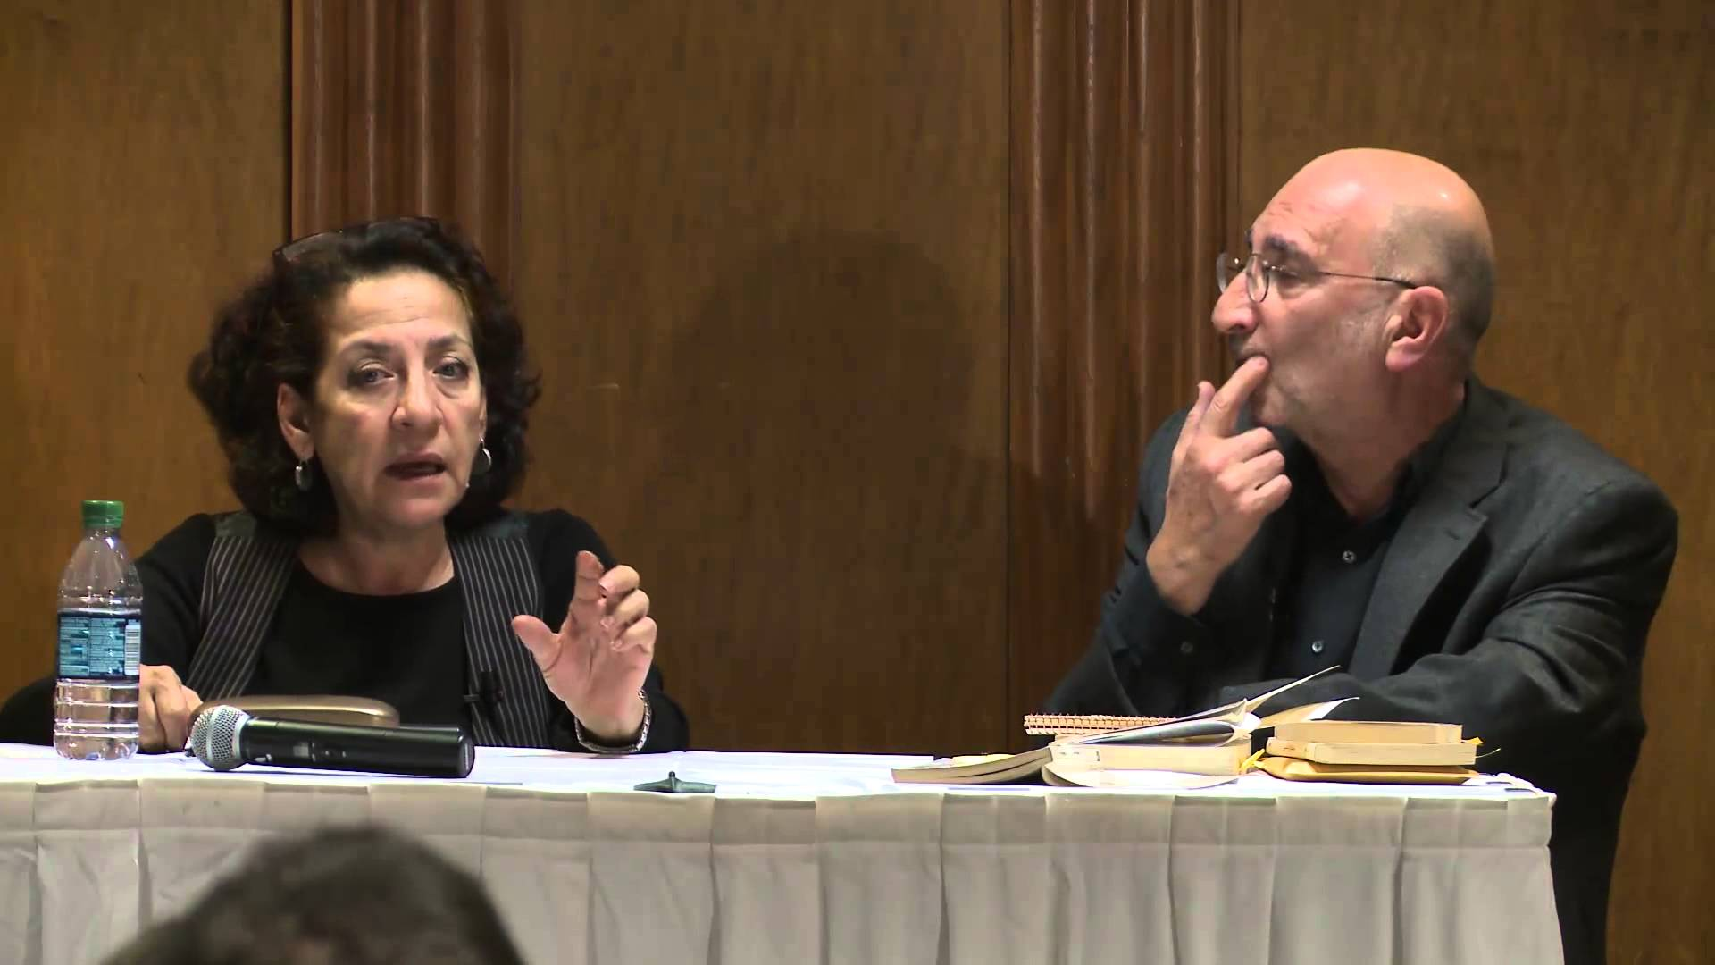

From University of Michigan faculty page
http://www.lsa.umich.edu/neareast/people/faculty/ci.shammasanton_ci.detail



Current edition of Arabesques (in English/USA) – University of California Press
http://www.ucpress.edu/book.php?isbn=9780520228320
